EX. NO.: 22
TITLE
DATABASE CONNECTIVITY USING PHP AND MYSQL
AIM
To execute the CREATE, INSERT, SELECT, UPDATE and DELETE commands in MySQL.

PROCEDURE
- Connect to the MySQL server.
- Select the MobileDB database.
- Create the emp table.
- Insert employee details into the table.
- Display the records using SELECT.
- Update the employee salary.
- Display the updated record.
- Delete the employee record.
- Display the final table and verify the result.

COMMANDS
1. Select Database
USE MobileDB;

2. Create EMP Table
CREATE TABLE emp
(
id INT PRIMARY KEY,
name VARCHAR(10) NOT NULL,
empsalary INT NOT NULL
);

3. Insert Record
INSERT INTO emp
(id, name, empsalary)
VALUES
(312, 'RANA', 200000);
4. Display Records
SELECT * FROM emp;

5. Update Employee Salary
UPDATE emp
SET empsalary = 9000000
WHERE id = 312;

6. Display After Updation
SELECT * FROM emp;

7. Delete Record
DELETE FROM emp
WHERE id = 312;

8. Display After Deletion
SELECT * FROM emp;
OUTPUTS
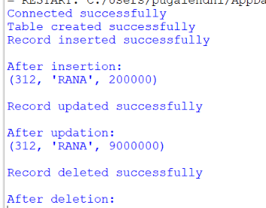

RESULT
Thus the CREATE, INSERT, SELECT, UPDATE and DELETE commands were executed successfully using MySQL.

